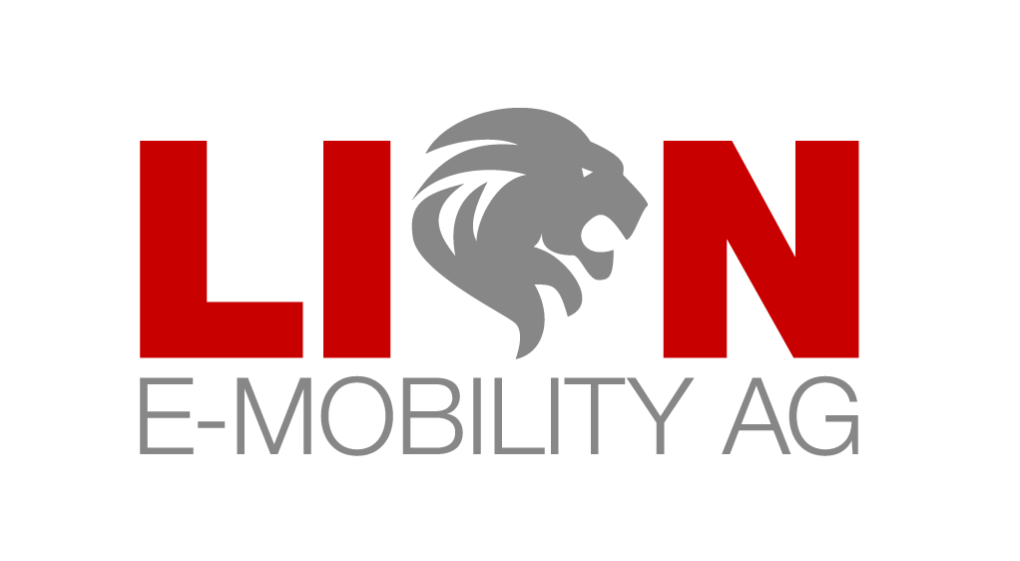

Sender: Name/Company · Street · Place · Country
LION E-Mobility AG  Chamerstrasse 172  6300 Zug  Switzerland |  | E-Mail: info@lionemobility.de  Website: www.lionemobillity.de  Date: XX.MM.20JJ

Confirmation

Dear Sir or Madam,

I hereby confirm that as of today I/we own (number) shares of LION E-Mobility AG.

Please enter my data in the share register:

For private individuals:

Surname, first names

Address

Nationality

For companies:

Company name

Commercial register entry

Registered office

Legal representative

Kind regards

